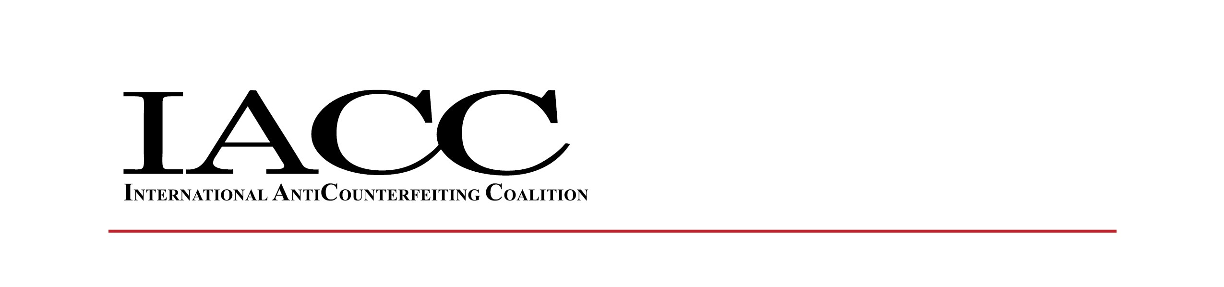

727 15
th

Street NW


9
th

Floor



Washington, DC 20005



USA


+1(202)223
-
6667



iacc@iacc.org


www.iacc.org

Public-Private Partnership in IP Enforcement -
Brief Timeline

2007 / 2008

First reports from IACC members re: CBP personnel’s growing reluctance to share (unredacted / unaltered) digital images and physical samples of suspected counterfeit imports.

2008 - 2010

Rights-holders engage directly with CBP to highlight concerns re: practice of redacting images / info; physically removing markings from product / packaging prior to provision of samples for examination.

Additional engagement with Office of the Intellectual Property Enforcement, FBI, DOJ, HSI. Consensus view was that CBP / Treasury view of Trade Secrets Act applicability was in error, but CBP remained insistent that, absent a change in statutes, their hands were tied.

2010 – 2011

Rights-holders engage with Congress, seeking to develop a legislative fix for the issue, clarifying CBP’s legal authority to disclose information to IP owners when seeking assistance in carrying out the agency’s IP enforcement mission.

Those efforts lead to enactment of Sec. 818(g) of the National Defense Authorization Act for Fiscal Year 2012, enacted Dec. 31, 2011. The provision states, “…the Secretary of the Treasury may share information appearing on, and unredacted samples of, products and their packaging and labels, or photographs of such products, packaging, and labels, with the rightholders of the trademarks suspected of being copied or simulated for purposes of determining whether the products are prohibited from importation pursuant to such section.”

2012 – 2015

In early 2012, CBP published an Interim Rule aimed at implementing the authority provided by Sec. 818(g), but in doing so imposed significantly greater restrictions on its disclosures than was intended by Congress. CBP determined that even if disclosures did not run afoul of the Trade Secrets Act, it should still seek to protect potentially sensitive commercial information to the extent possible. The “7-day waiting period” is the end result.

In comments to CBP following the publication of the Interim Rule, rights-holders voiced concerns that the new procedures would decrease the efficiency and effectiveness of enforcement by CBP. Despite the concerns registered by rights-holders, CBP ultimately finalized its implementation of Section 818(g) in September of 2015, publishing a Final Rule that was largely unchanged from the Interim Rule.

In 2014 / 2015, CBP launched a pilot program aimed at providing an expedited pathway for handling suspected illicit imports. Though rights-holders were supportive of the concept, CBP refused to disclose *any* information regarding suspected counterfeit shipments, again claiming that any such disclosures were barred by the Trade Secrets Act. Even “post-abandonment” disclosures were deemed impermissible, further hampering cooperative enforcement and self-help by rights-holders. (In 2019, CBP published an NPRM to create a framework for sharing information in connection with such abandoned shipments, but has failed, to date, to finalize those regulations.)

2015 – 2016

The protracted timeline for CBP’s implementation of Section 818(g) and the substance of the Final Rule led many stakeholders to pursue additional legislative action to resolve their concerns. That engagement led to Congress’ enactment of 19 USC 1628a in early 2016, as part of the Trade Facilitation & Trade Enforcement Act (Sec. 302).

2016 – 2019

Implementation of that law was even more protracted – CBP did not issue a NPRM until 2019, despite receiving comments from only 6 stakeholders.

2020 - 2025

Nearly 9 years after TFTEA’s enactment, CBP issued its final rule in connection with the TFTEA provisions, adopting only limited changes to its anti-counterfeiting enforcement framework, focusing instead on efforts to harmonize its procedures for other types of IP (e.g., copyrights, circumvention devices) with those governing trademark enforcement.
Further efforts at resolving CBP’s concerns via legislation have continued in the intervening years, including bills introduced by Senator Grassley in the 117th and 118th Congresses, amendments offered in connection with other significant trade packages (e.g., USICA, America COMPETES, etc.), and in connection with more comprehensive reviews of our trade enforcement framework (e.g., CBP’s 21st Century Customs Framework initiative, Sen. Cassidy’s “Customs Modernization Act,” etc.).

